**Software Testing and Quality Assurance**

**2CSDE80**

**Roll No.: 22BCE501**

**PRACTICAL 6: To perform automated functional GUI testing using Sikuli tool Testing LMS GUI**

Test Case1: Navigating to the course

Status: Pass

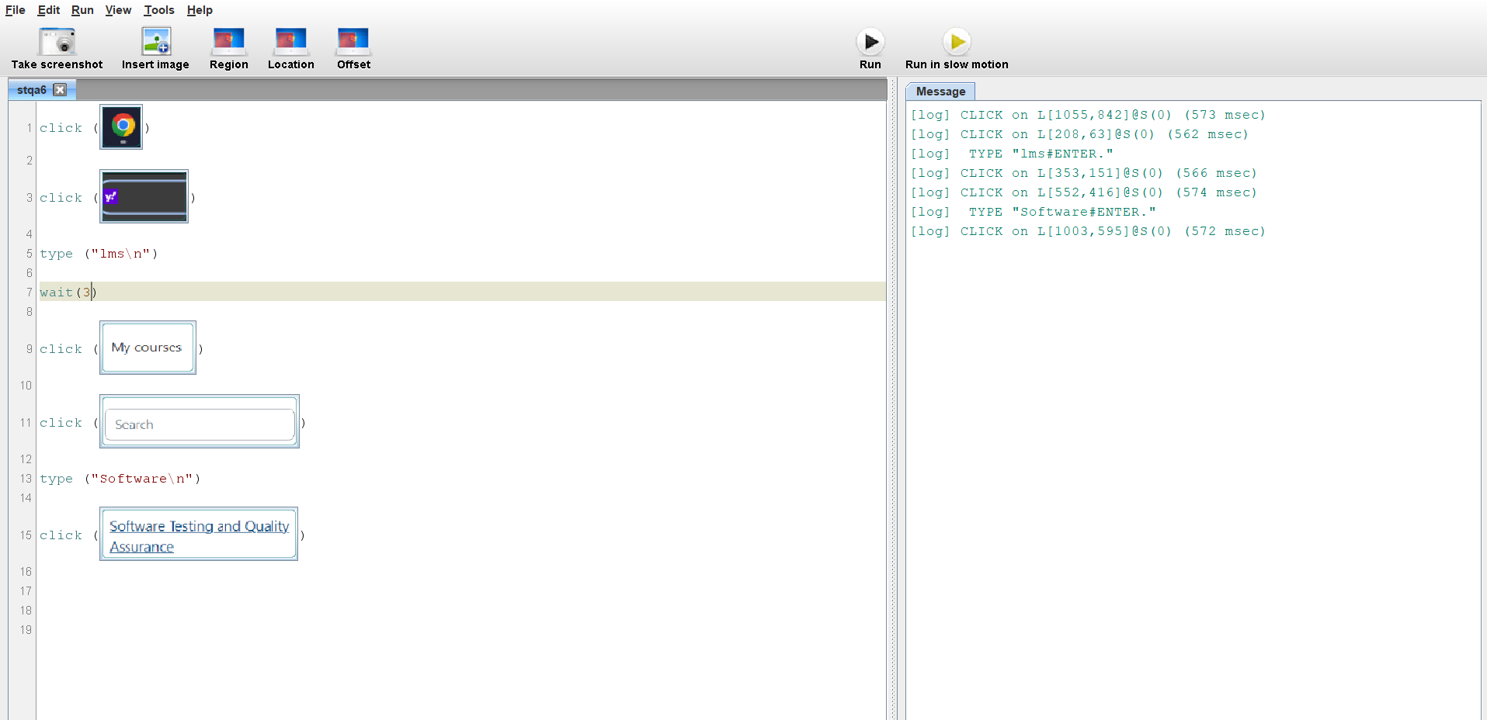

Test Case2: Sending a Message to fellow classmate

Status: Pass

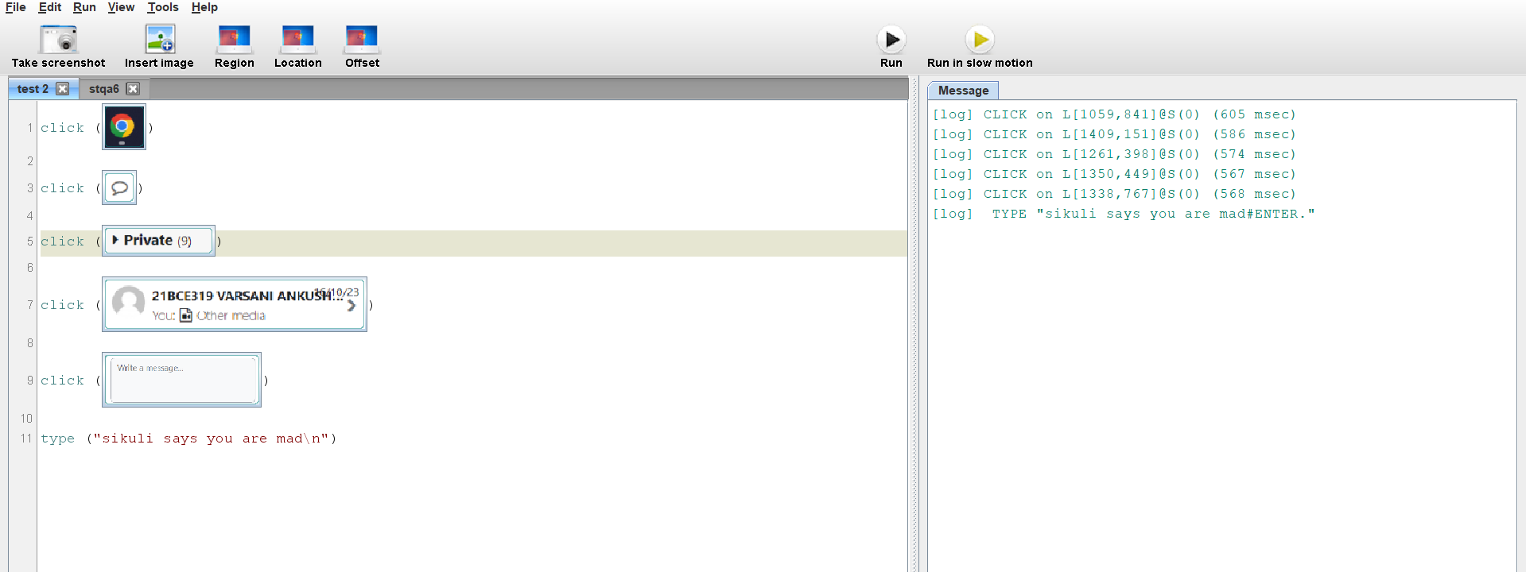

Test Case3: Uploading a File

Status: Pass

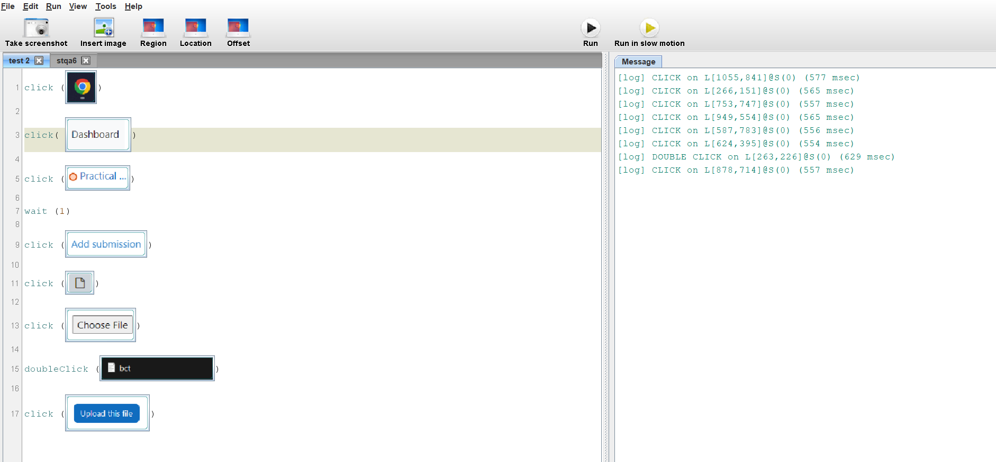

Test Case4: Downloading course material

Status: Pass

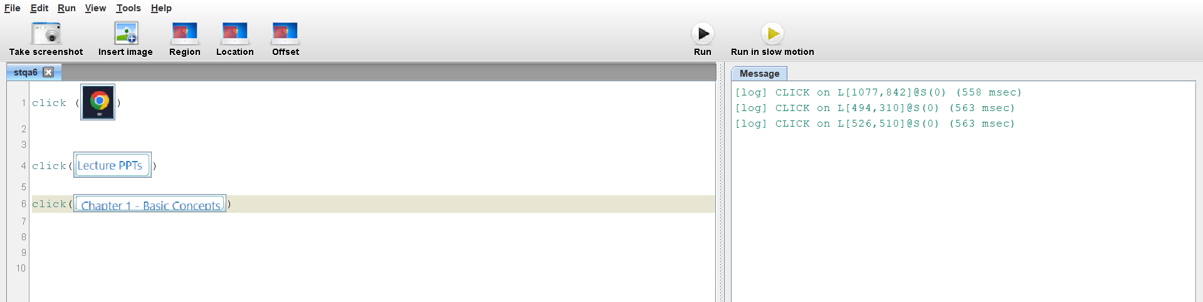

Test Case5: changing notification settings

Status: Pass

